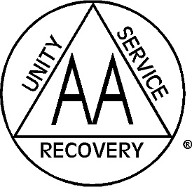

Committee Volunteers Are Needed
The following committee positions are open to anyone who is ready to help. If any of these sound appealing to you, join us at the District Meetings or call the District information line.
- *Eastern Missouri Summer Assembly in Palmyra*
- Bridging the Gap
- Corrections
- Cooperation with the Professional Community (CPC)
- Grapevine
- Public Information
- Technology
- Structure and Procedure
- Missouri State Convention
Other positions available throughout our district are G.S.R.’s and District Secretary. If you are interested in filling any role, talk to your sponsor or contact the District Information Line.

District 13 Information:
(573) 231-5818
http://eamo13.wix.com/district13

